**Program No: 09**

**Name: Sanio Luke Sebastian**

**Roll No: 35**

**Batch: B**

**Date: 03-06-2022**

**Aim:** Query Processing : Performing CRUD operations

with NoSQL database.

**Procedure & Outputs:**

1. Display available Databases and selecting the desired database.

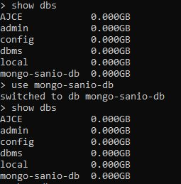

1. Creating collection in the database.





1. Insertion of fields
   1. Insert: Inserts entered queried documents into the collection.

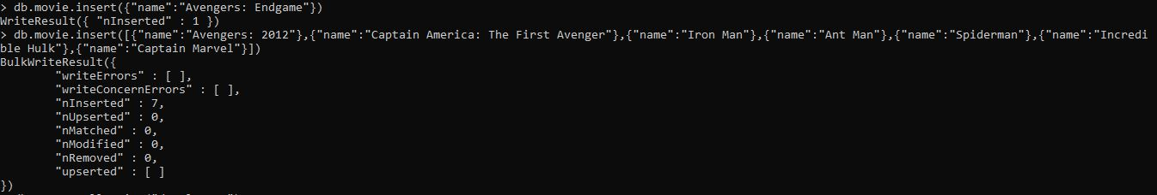

* 1. InsertMany: Inserts multiple documents into the collection at same time.



* 1. InsertOne: Inserts only one documents into the collection.



1. Find fields and documents using filters

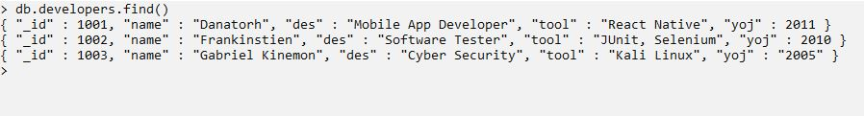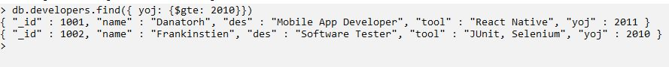

1. Update fields according to the filter query conditions
   1. UpdateOne: Updates only one document.

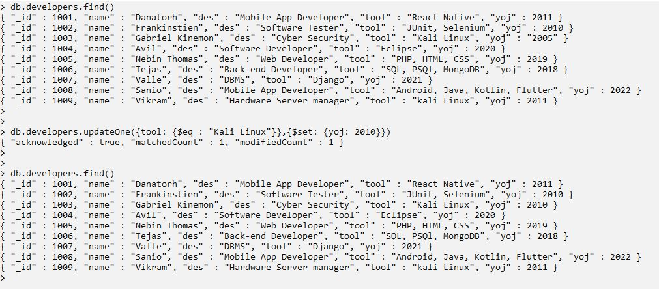

* 1. UpdateMany: Updates multiple documents according to the query from the collection.

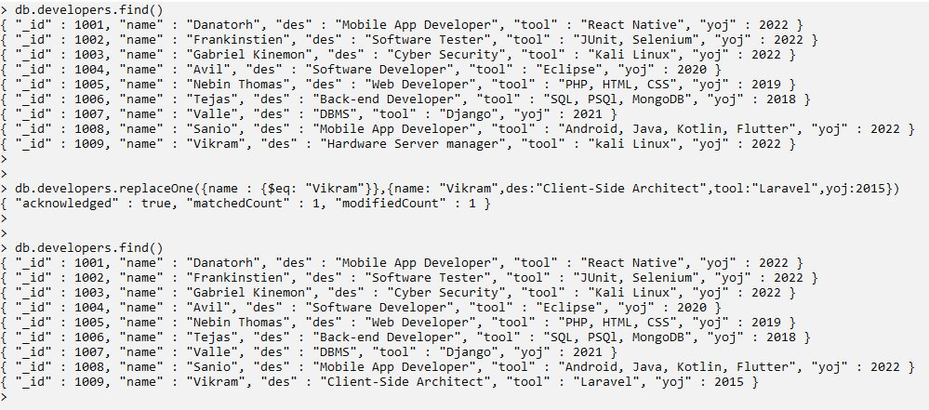

* 1. replaceOne: Replace the whole specified document with the new values.



1. Delete documents according to specified conditions.
   1. DeleteOne: Deletes only one documents according to the condition.

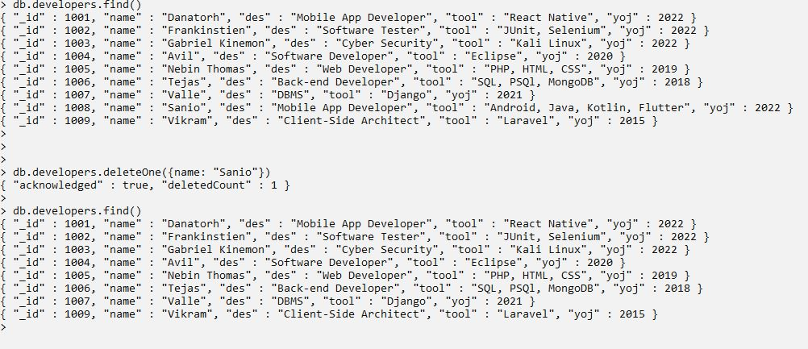

* 1. DeleteMany: Deletes all the documents that satisfies the condition.

